527 — Computer Networks and Distributed Systems — Assessed Coursework: RMI and UDP

**User Datagram Protocol**

UDP mechanism involves sending information in the form of packets called Datagrams. In this example, we were sending information contained in the common class called MessageInfo, which contains an integer of the number of messages to be sent and a message number identifier.

The mechanism was used to send information of increasing size, starting from 20 messages up to 2000. The results showed a clear increase in lost packets after 300 messages. Messages up to the 300 point were safely delivered. The pattern formed following that was messages were lost in sequential blocks. For example, messages of size 500 occurred to have an instance of sequential losses, while 2000 had about 2-3 blocks of sequential losses.

The main cause of the loss of messages in a UDP mechanism is the lack of overheads. This means messages are simply sent however, there are no checks made to ensure they were safely transmitted in order or possibly duplicated. Furthermore, the more messages sent, the greater the congestion. UDP’s lack of congestion control, means if the port is overloaded, more packets are lost. No mechanism exists to retransmit lost data, so the chances of losing data is greater, as seen in the results. It was suggested to check the last message to confirm all messages had been sent however, this resulted in the server timing out if the last message did not arrive. This was a significant weakness of using UDP, as it caused often caused the server to timeout and the need for several attempts in sending before obtaining results.

**Remote Method Invocation**

RMI allows an object on a client machine to invoke remote method on another object running on a difference Java Virtual Machine, in this context, our server machine. It was found with RMI mechanism that there were no messages lost, even when sending a significant number of messages.

This is because RMI transmits and checks whether a message has been sent, then retransmit it to ensure all messages are sent. This means problems such as buffer overflows and network congestion at the receiver end are taken care of. The only downside was an increased time as more messages were sent due to more overheads as messages had to be checked for receipt.

**Conclusion**

From the results, RMI was far more reliable than UDP. At significantly high levels of messages, there were no lost messages, while UDP failed to send several messages after 300. Furthermore, the process of coding RMI was easier as sending and receiving information was dynamically handled by encapsulated marshalling arguments, while in UDP, the process of sending packets and ports had to be manually configured. There was no need to understand how the client communicated with the server, due to the abstraction of the RMI. Although, it was found running UDP was often faster than RMI due to the lack of overheads.

|  |  |  |  |
| --- | --- | --- | --- |
| UDP |  |  |  |
| No.   Messages Sent | Average   No. Received | Average   No. Lost | Percentage   loss |
| 20 | 20 | 0 | 0 |
| 40 | 40 | 0 | 0 |
| 60 | 60 | 0 | 0 |
| 80 | 80 | 0 | 0 |
| 100 | 100 | 0 | 0 |
| 200 | 200 | 0 | 0 |
| 300 | 300 | 0 | 0 |
| 400 | 350 | 50 | 12.5 |
| 500 | 376 | 124 | 24.8 |
| 1000 | 788 | 212 | 21.2 |
| 2000 | 1134 | 866 | 43.3 |

Figure 1: UDP results taken over an average of ten readings

|  |  |  |
| --- | --- | --- |
| RMI | | |
| No. Messages Sent | Average No. Received | Average No. Lost |
| 20 | 20 | 0 |
| 40 | 40 | 0 |
| 60 | 60 | 0 |
| 80 | 80 | 0 |
| 100 | 100 | 0 |
| 200 | 200 | 0 |
| 300 | 300 | 0 |
| 400 | 400 | 0 |
| 500 | 500 | 0 |
| 1000 | 1000 | 0 |
| 2000 | 2000 | 0 |

Figure 2: RMI results taken over an average of ten readings

**Logs**

UDP Server

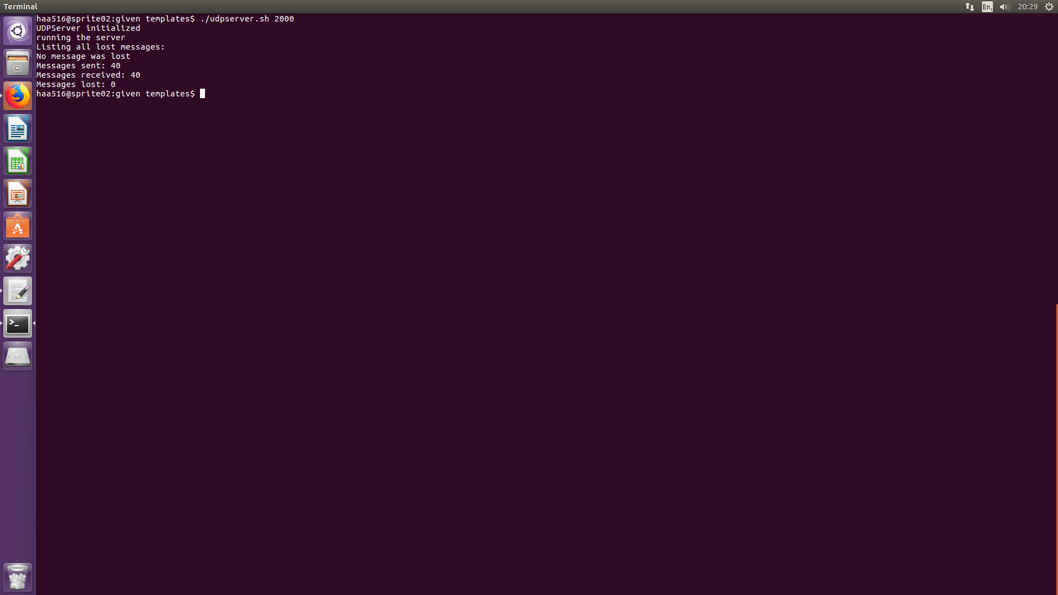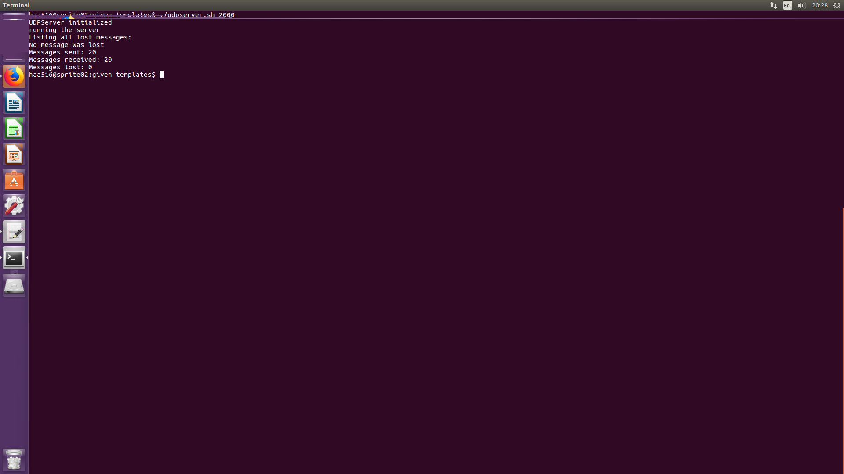

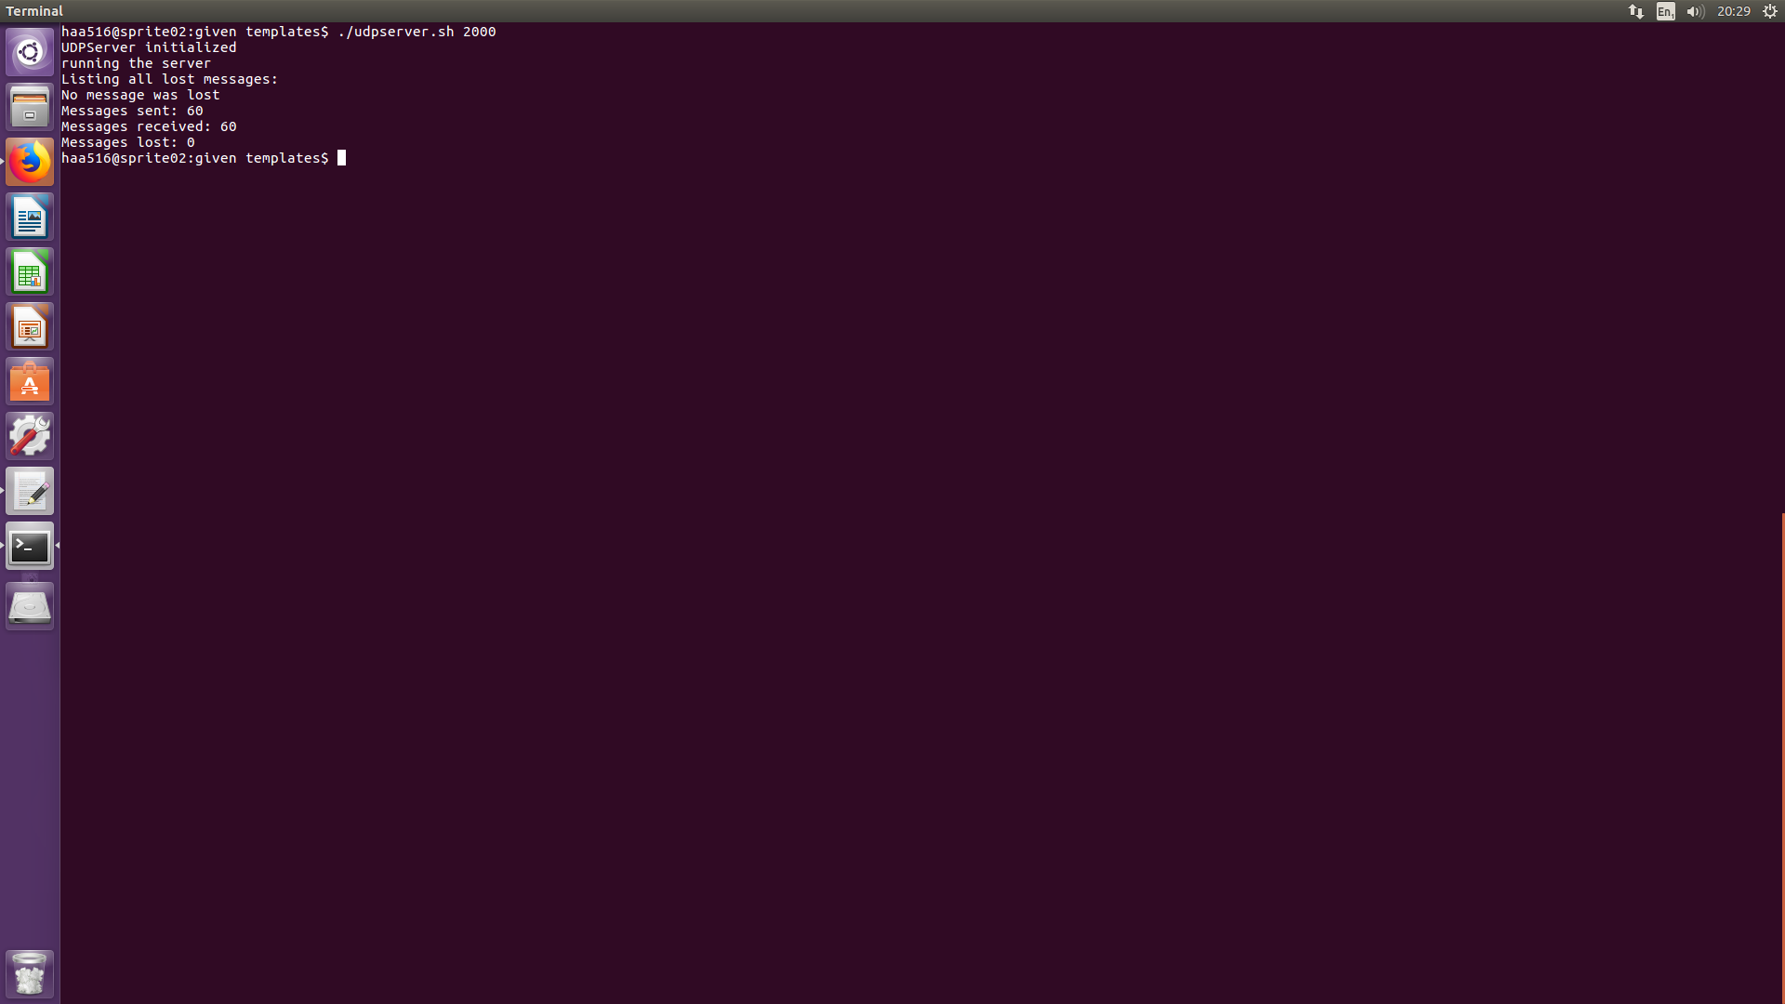

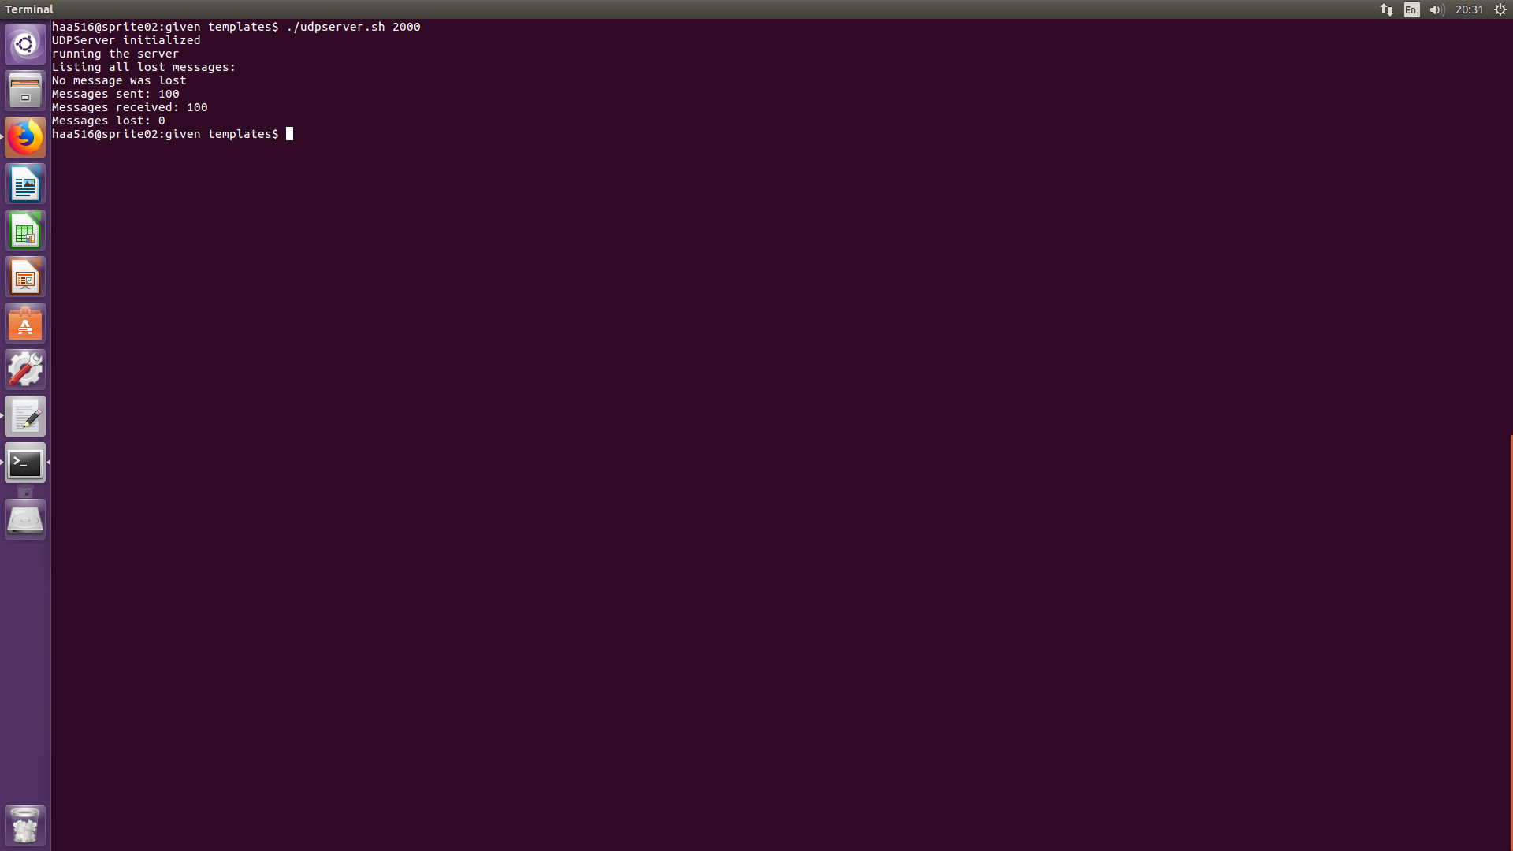

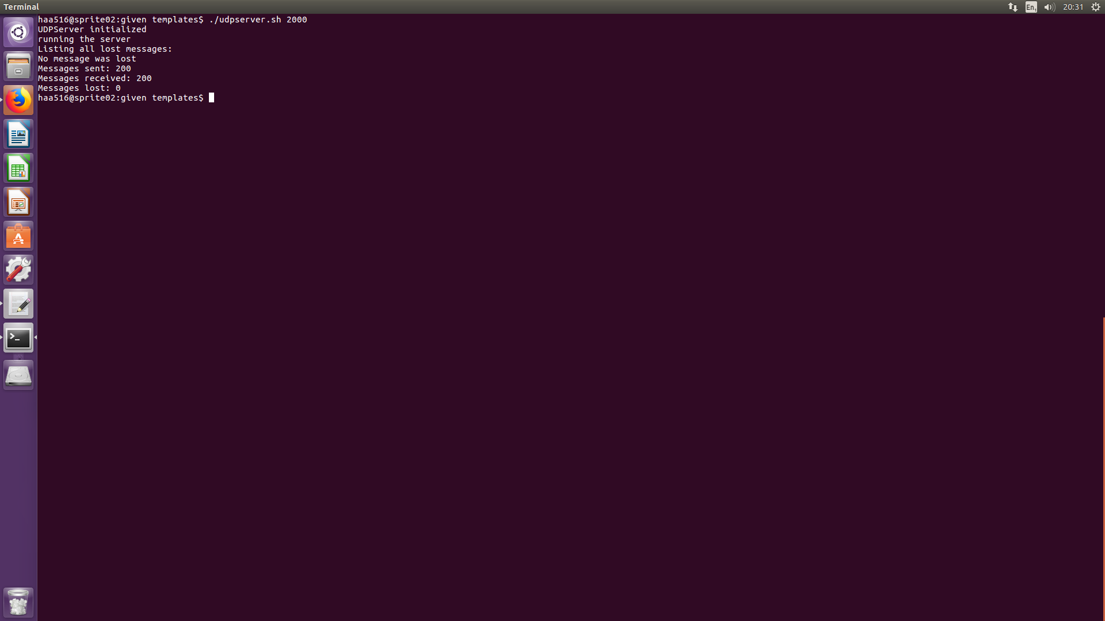

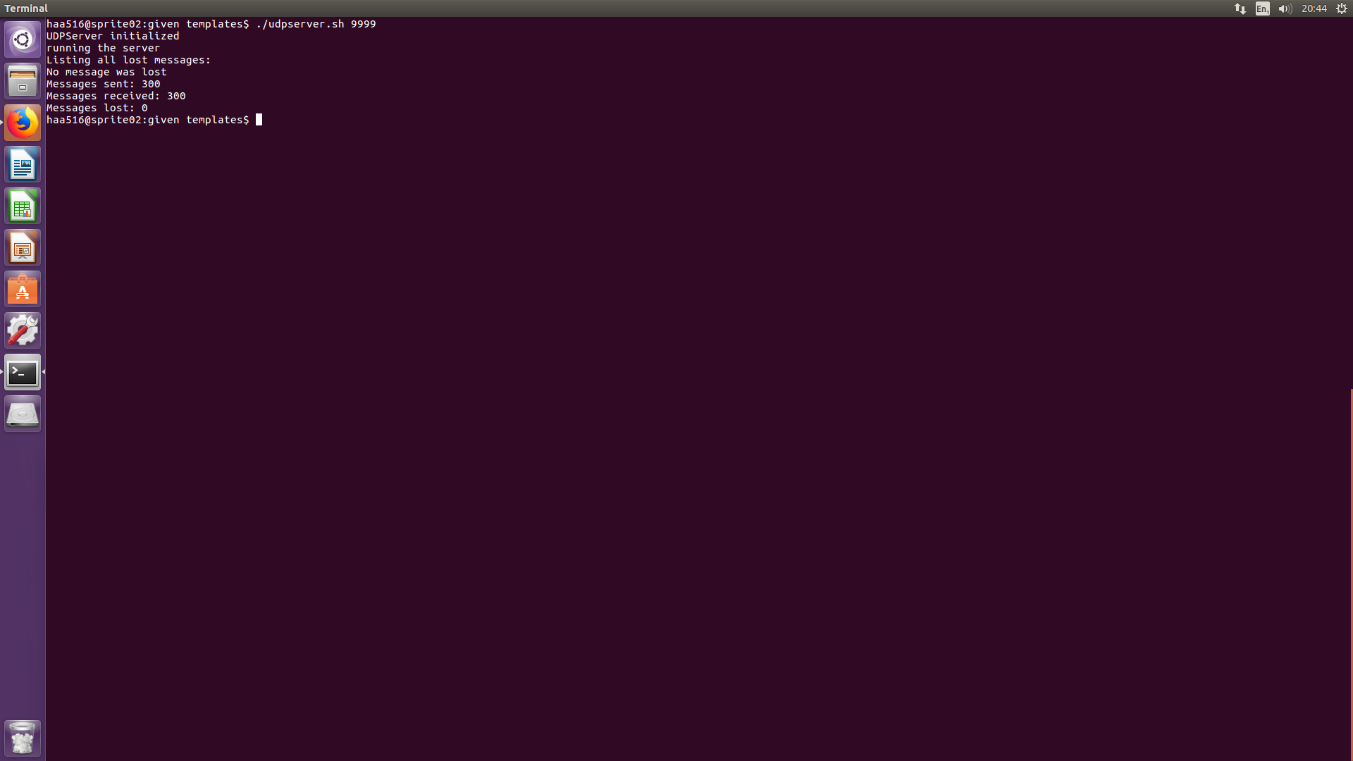

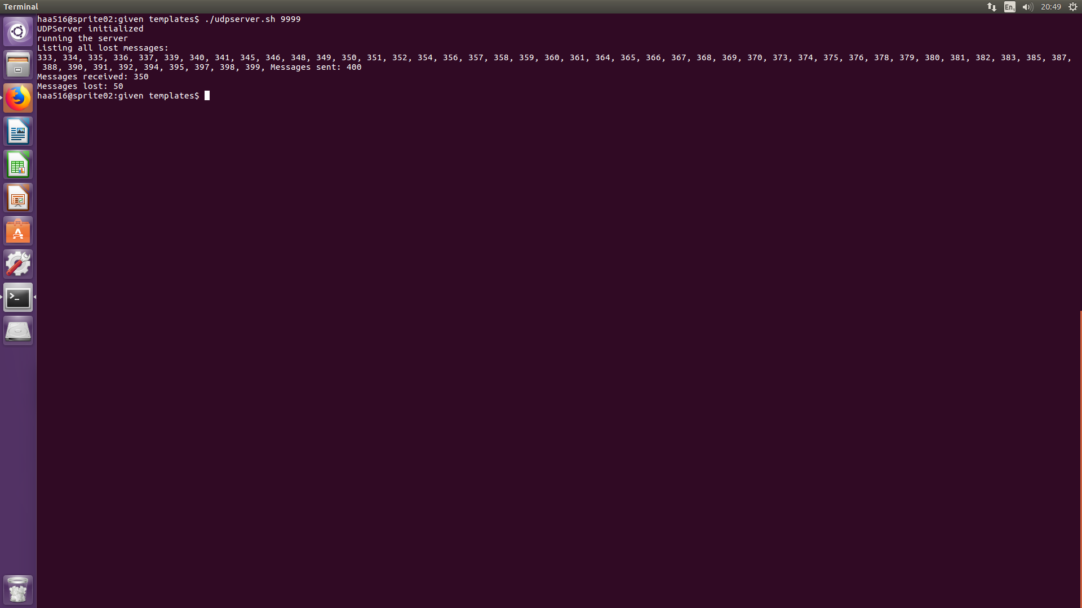

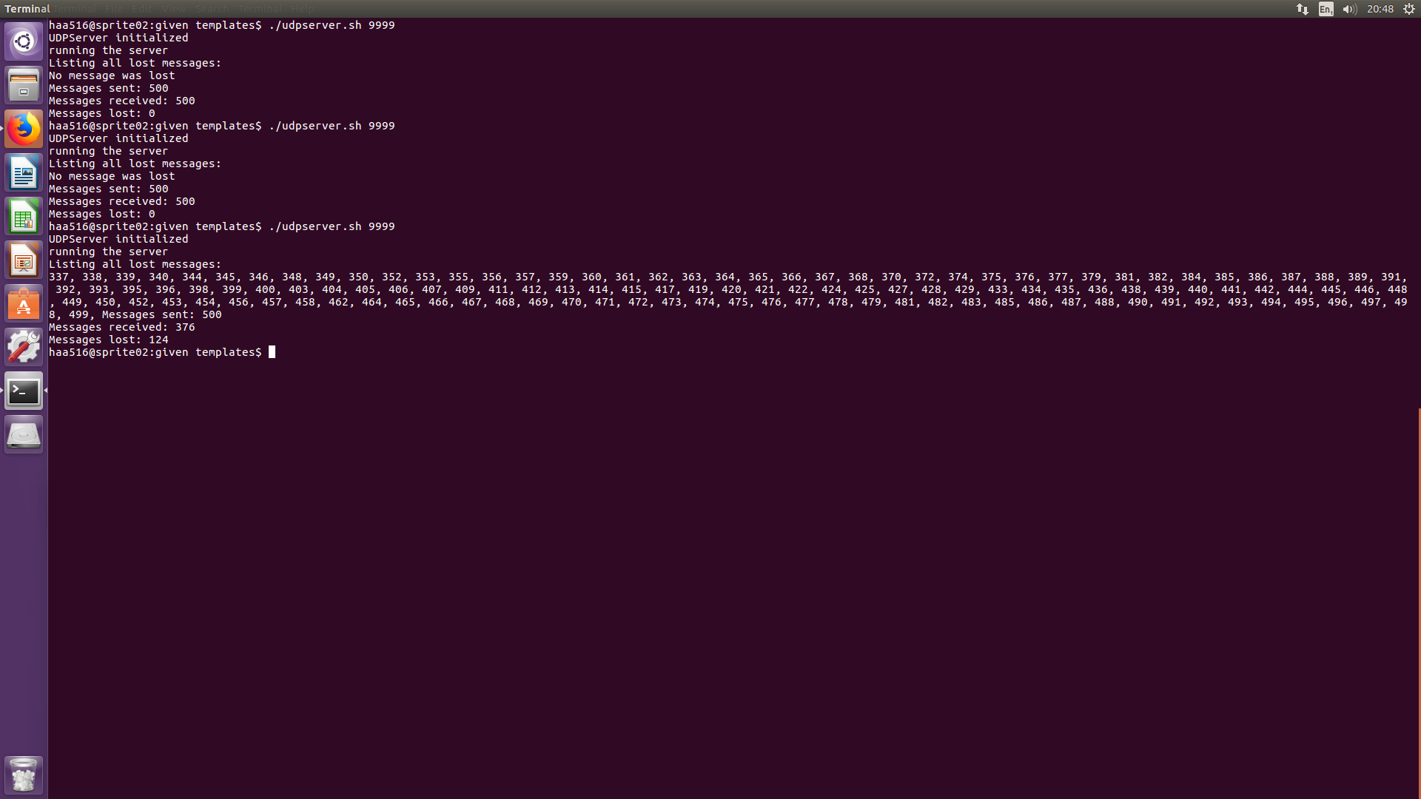

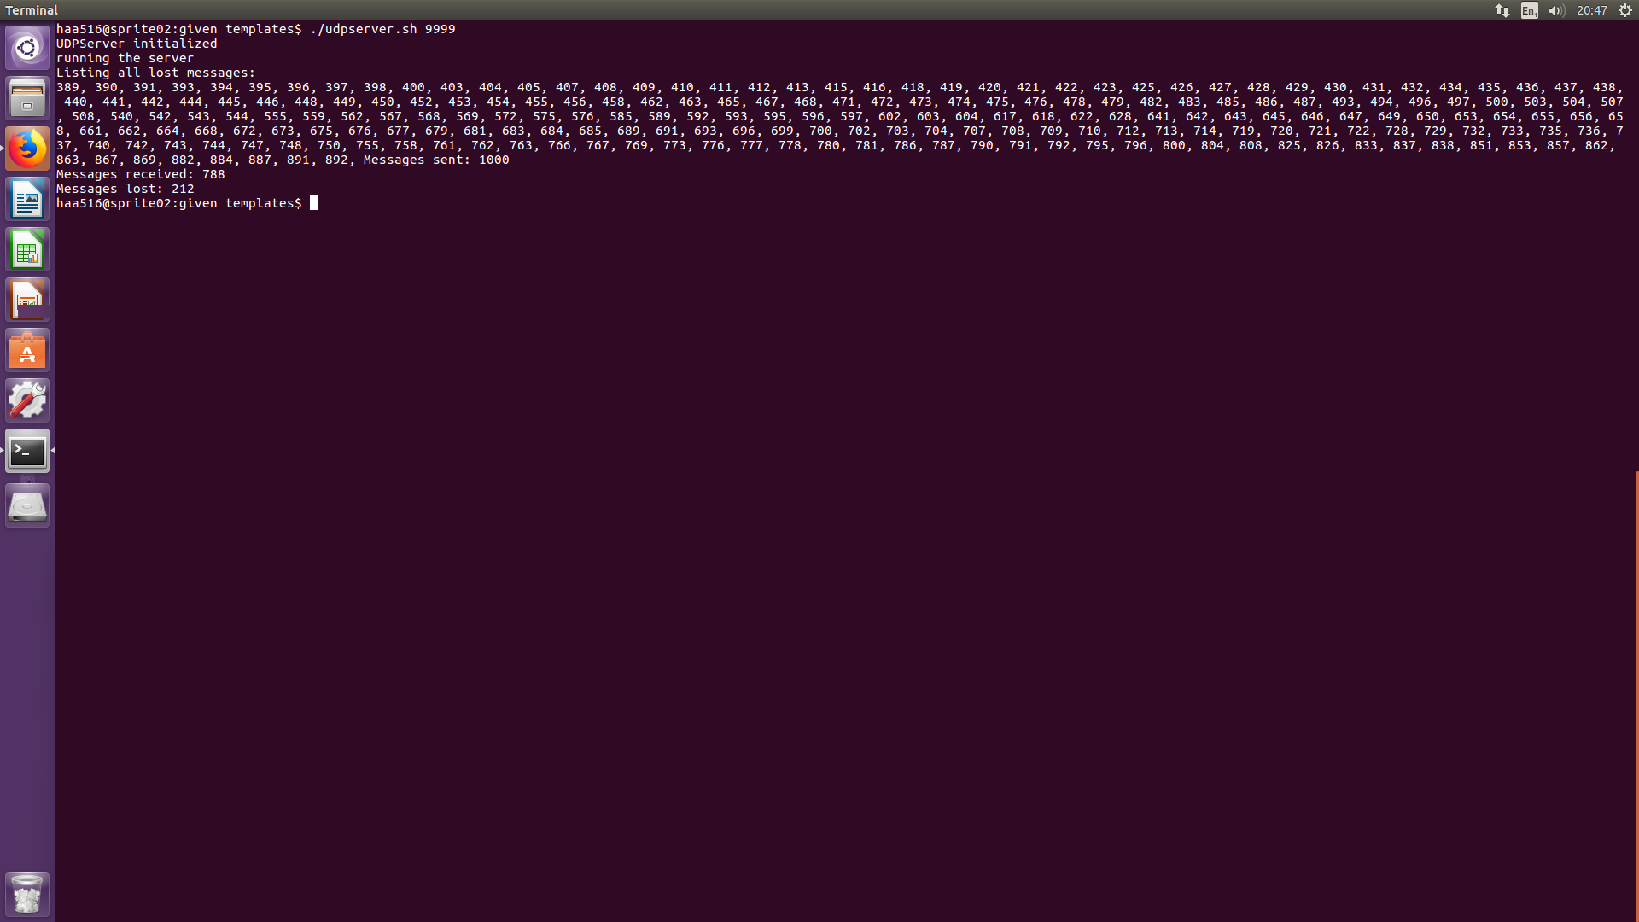

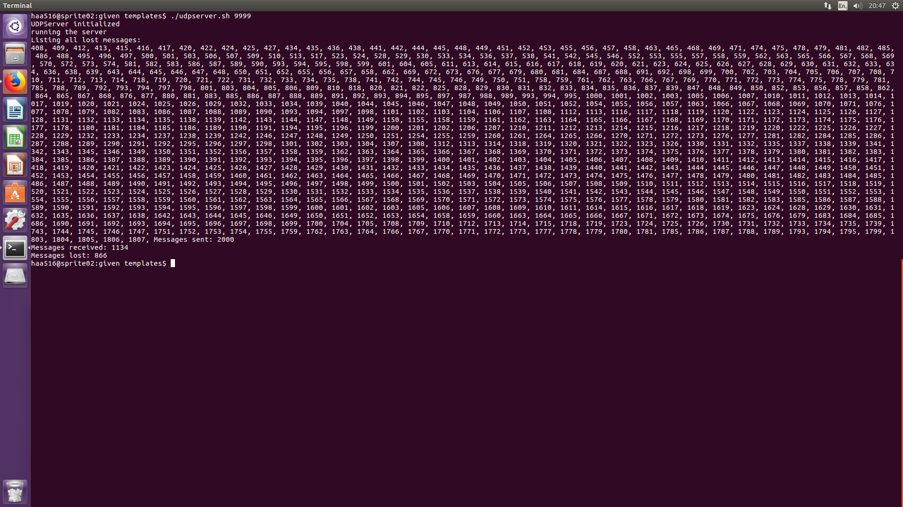

UDP Client

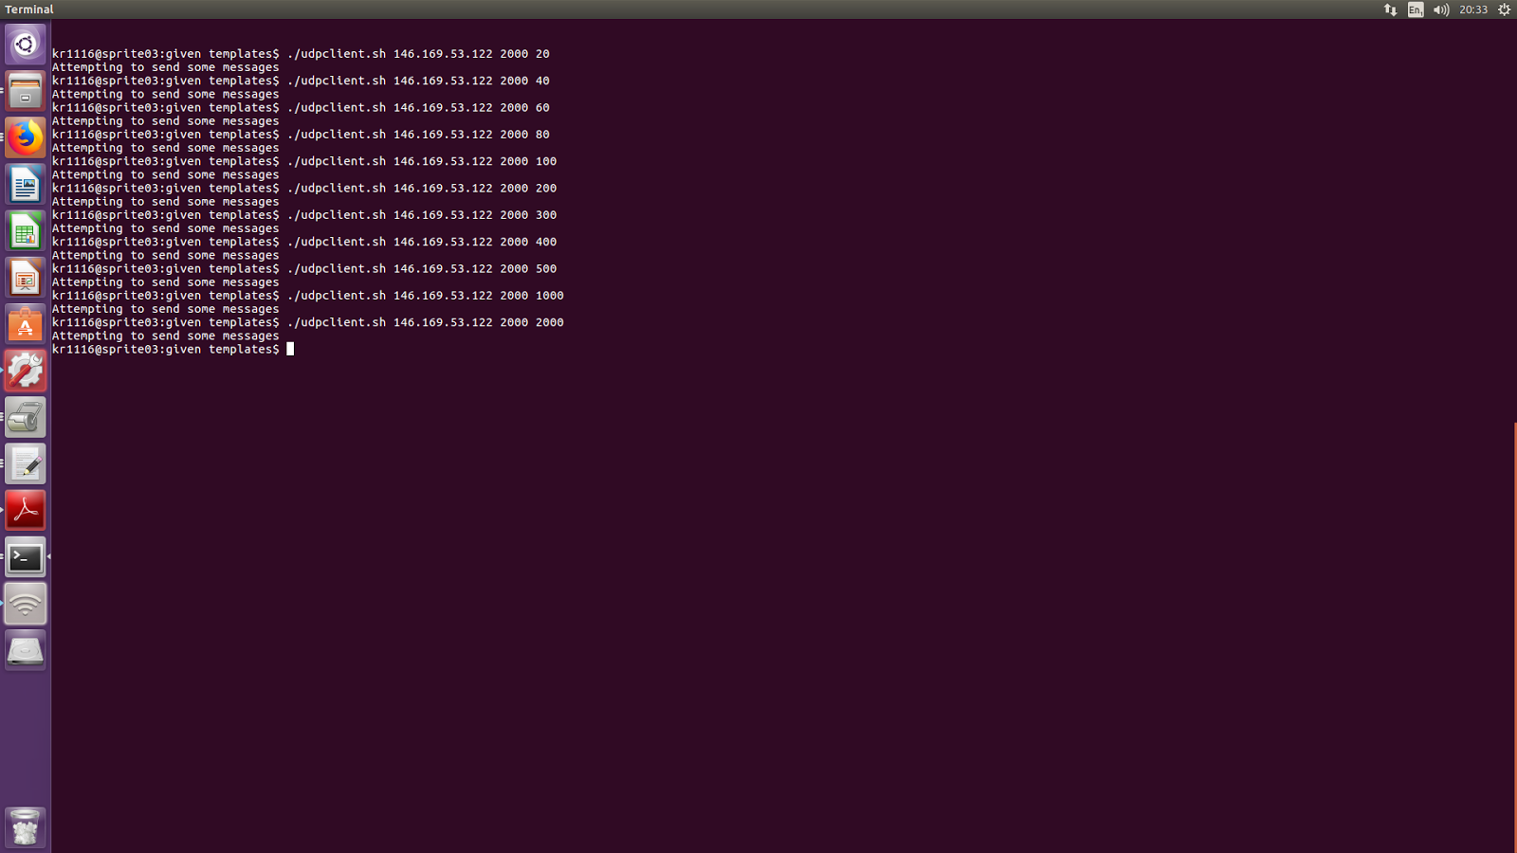

RMI Server

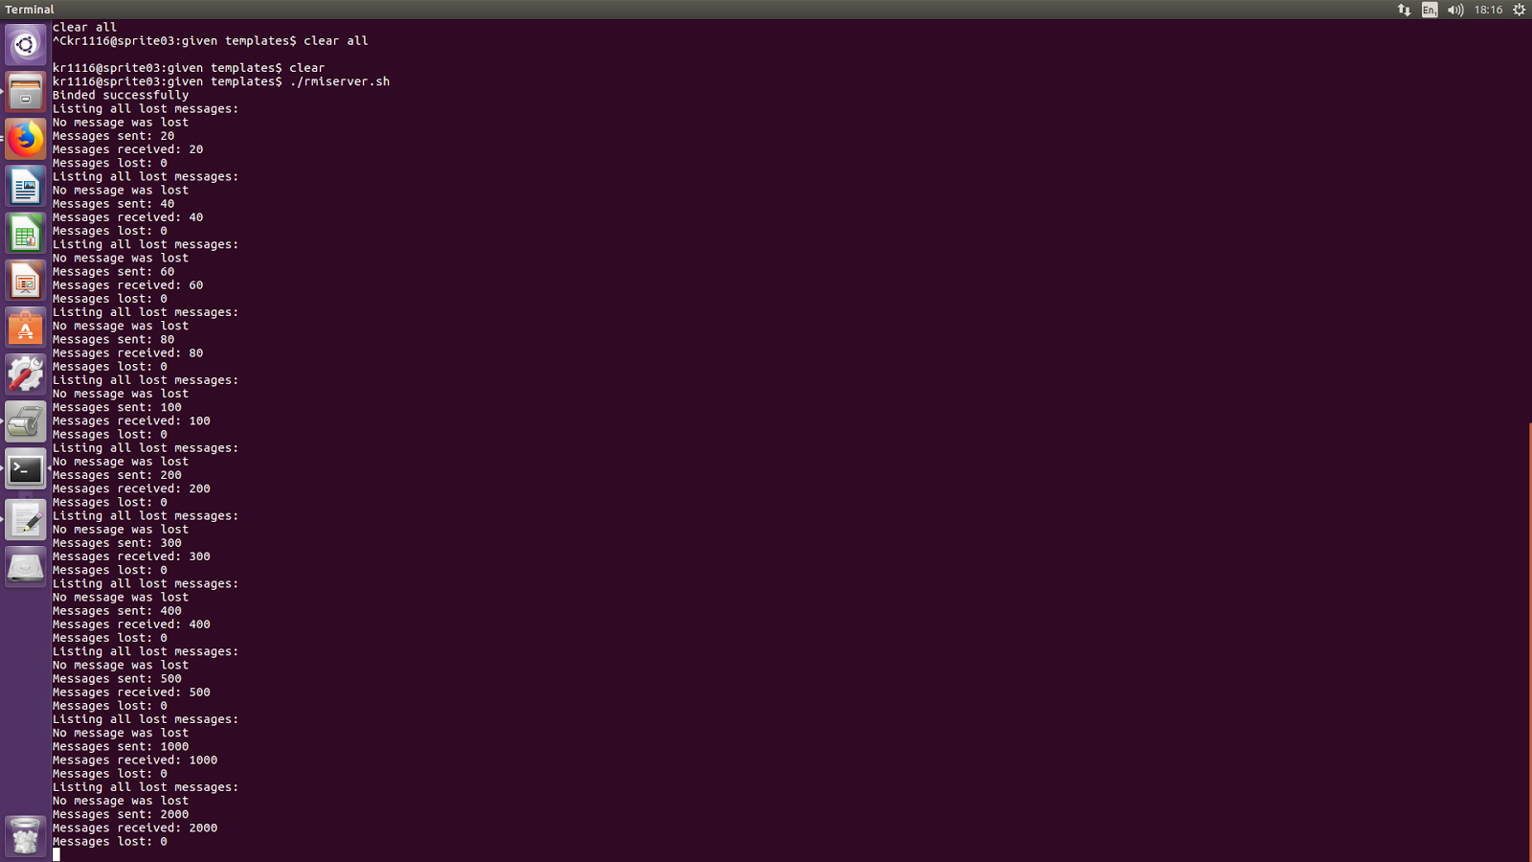

RMI client

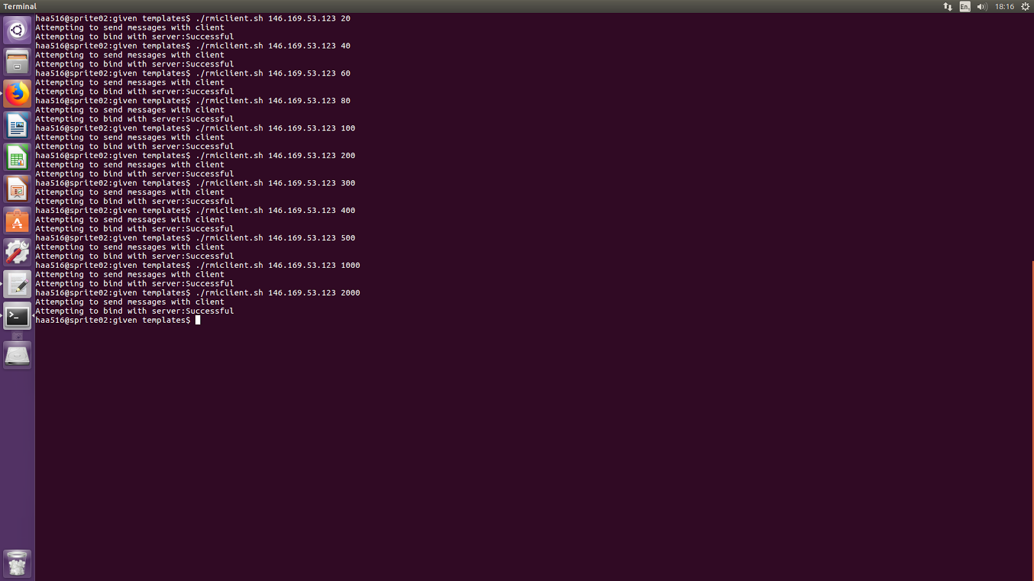

Completed Code:

1. RMI Client

package rmi;

import java.rmi.Naming;

import java.rmi.NotBoundException;

import java.rmi.RemoteException;

import java.rmi.registry.LocateRegistry;

import java.rmi.registry.Registry;

import java.rmi.RMISecurityManager;

import common.MessageInfo;

public class RMIClient {

public static void main(String[] args) {

System.out.println("Attempting to send messages with client");

RMIServerI iRMIServer = null;

// Check arguments for Server host and number of messages

if (args.length != 2){

System.out.println("Needs 2 arguments: ServerHostName/IPAddress, TotalMessageCount");

System.exit(-1);

}

String urlServer = new String("rmi://" + args[0] + "/RMIServer");

int numMessages = Integer.parseInt(args[1]);

// TO-DO: Initialise Security Manager

            //sets security manager

        System.setSecurityManager(new RMISecurityManager());

        try{

System.out.print("Attempting to bind with server:");

// TO-DO: Bind to RMIServer

            //checks the url for exceptions and bings the lookup server

        iRMIServer = (RMIServerI) Naming.lookup(urlServer);

System.out.println("Successful");

// TO-DO: Attempt to send messages the specified number of times

        for( int i=0; i<numMessages; i++){

            //creates a new message and calls RMI server receive this message

            MessageInfo msg = new MessageInfo(numMessages,i);

            iRMIServer.receiveMessage(msg);

        }

} catch (Exception e) {

System.out.println("Error in client");

}

}

}

1. RMI Server

/*

 * Created on 01-Mar-2016

 */

package rmi;

import java.net.MalformedURLException;

import java.rmi.Naming;

import java.rmi.registry.LocateRegistry;

import java.rmi.RemoteException;

import java.rmi.server.UnicastRemoteObject;

import java.util.Arrays;

import java.rmi.registry.Registry;

import common.*;

public class RMIServer extends UnicastRemoteObject implements RMIServerI {

private int totalMessages = -1;

private int[] receivedMessages;

public RMIServer() throws RemoteException {

}

public void receiveMessage(MessageInfo msg) throws RemoteException {

// TO-DO: On receipt of first message, initialise the receive buffer

            //initialises the array

        if(receivedMessages == null){

            totalMessages = msg.totalMessages;

            receivedMessages = new int[msg.totalMessages];

        }

System.out.println("Recieving messages");

// TO-DO: Log receipt of the message

            //verifies a recepit of a message in the array

        receivedMessages[msg.messageNum] = 1;

// TO-DO: If this is the last expected message, then identify

//        any missing messages

            //note: that if it didn't receive the last message all the messages would not be logged

        if(msg.messageNum + 1 == totalMessages){

            System.out.println("Listing all lost messages: ");

            int count = 0;

            for(int i=0; i<totalMessages; i++) {

                if (receivedMessages[i] != 1) {

                    count++;

                    System.out.print(i+1 + ", ");

                }

            }

            if (count == 0){

                System.out.println("No message was lost");

            }

            System.out.println("Messages sent: " + totalMessages);

            System.out.println("Messages received: " + (totalMessages - count));

            System.out.println("Messages lost: " + count);

    receivedMessages = null;

        }

}

public static void main(String[] args) {

RMIServer rmiserv = null;

// TO-DO: Initialise Security Manager

        if (System.getSecurityManager() == null){

            System.setSecurityManager(new SecurityManager());

        }

try{

// TO-DO: Instantiate the server class

        rmiserv = new RMIServer();

// TO-DO: Bind to RMI registry

        rebindServer("RMIServer", rmiserv);

System.out.println("Binded successfully");

} catch(Exception e) {

System.out.println("Error in RMISERV");

}

}

protected static void rebindServer(String serverURL, RMIServer server) {

try{

// TO-DO:

// Start / find the registry (hint use LocateRegistry.createRegistry(...)

// If we *know* the registry is running we could skip this (eg run rmiregistry in the start script)

        LocateRegistry.createRegistry(1099);

// TO-DO:

// Now rebind the server to the registry (rebind replaces any existing servers bound to the serverURL)

// Note - Registry.rebind (as returned by createRegistry / getRegistry) does something similar but

// expects different things from the URL field.

        Naming.rebind(serverURL, server);

} catch (Exception e){

System.out.println("Error binding");

}

}

}

1. UDP Client

/*

 * Created on 01-Mar-2016

 */

package udp;

import java.io.IOException;

import java.net.DatagramPacket;

import java.net.DatagramSocket;

import java.net.InetAddress;

import java.net.SocketException;

import java.net.UnknownHostException;

import java.io.*;

import common.MessageInfo;

public class UDPClient {

private DatagramSocket sendSoc;

public static void main(String[] args) {

InetAddress serverAddr = null;

//Inetaddress class representing an IP address

int recvPort;

int countTo;

String message;

// Get the parameters

if (args.length != 3) {

System.err.println("Arguments required: server name/IP, recv port, message count");

System.exit(-1);

}

try {

serverAddr = InetAddress.getByName(args[0]);

//gets host's ip address given the host name

} catch (UnknownHostException e) {

System.out.println("Bad server address in UDPClient, " + args[0] + " caused an unknown host exception " + e);

System.exit(-1);

}

recvPort = Integer.parseInt(args[1]);

countTo = Integer.parseInt(args[2]);

//parseInt--string to integer variable

// TO-DO: Construct UDP client class and try to send messages

UDPClient client = new UDPClient();

//UDP client is a class and initialised here

System.out.println("Attempting to send some messages");

client.testLoop(serverAddr, recvPort, countTo);

}

public UDPClient() {

// TO-DO: Initialise the UDP socket for sending data

try {

sendSoc = new DatagramSocket();

} catch (SocketException e) {

System.out.println("Socket error");

}

}

private void testLoop(InetAddress serverAddr, int recvPort, int countTo) {

int tries = 0;

// TO-DO: Send the messages to the server

MessageInfo mess;

ByteArrayOutputStream byteStream;

ObjectOutputStream oos;

for(int i = 0; i < countTo; i++) {

mess = new MessageInfo(countTo,i);

//thought 2000 would be enough

byteStream = new ByteArrayOutputStream(60000);

try {

oos = new ObjectOutputStream(new BufferedOutputStream(byteStream));

oos.writeObject(mess);

oos.flush();

} catch (Exception e) {

System.out.println("Error doing the client stream");

System.exit(-1);

}

byte[] sendByteArr = byteStream.toByteArray();

send(sendByteArr, serverAddr, recvPort);

}

}

private void send(byte[] data, InetAddress destAddr, int destPort) {

DatagramPacket pkt;

// TO-DO: build the datagram packet and send it to the server

pkt = new DatagramPacket(data, data.length, destAddr, destPort);

try {

sendSoc.send(pkt);

} catch (IOException e) {

System.out.println("Error sending");

System.exit(-1);

}

}

}

1. UDP Server

package udp;

import java.io.IOException;

import java.net.DatagramPacket;

import java.net.DatagramSocket;

import java.net.SocketException;

import java.net.SocketTimeoutException;

import java.util.Arrays;

import java.io.*;

import common.MessageInfo;

public class UDPServer {

private DatagramSocket recvSoc;

private int totalMessages = -1;

private int[] receivedMessages;

private boolean close;

private void run() throws SocketTimeoutException{

int pacSize;

byte[] pacData;

DatagramPacket pac;

// TO-DO: Receive the messages and process them by calling processMessage(...).

//        Use a timeout (e.g. 30 secs) to ensure the program doesn't block forever

while(!close){

//pacsize is randomly chosen has to match client.java we thought 2000 would be enough

pacSize = 60000;

pacData = new byte[60000];

pac = new DatagramPacket(pacData, pacSize);

try {

//thought this would be 30 seconds as it's in milliseconds

recvSoc.setSoTimeout(30000);

recvSoc.receive(pac);

} catch (IOException e) {

System.out.println("Error receiving packet");

System.exit(-1);

}

processMessage(pac.getData());

}

}

public void processMessage(byte[] data) {

MessageInfo msg = null;

// TO-DO: Use the data to construct a new MessageInfo object

ByteArrayInputStream byteStream = new ByteArrayInputStream(data);

ObjectInputStream ois;

try {

ois = new ObjectInputStream(new BufferedInputStream(byteStream));

msg = (MessageInfo) ois.readObject();

ois.close();

} catch (Exception e) {

System.out.println("Error creating the stream");

System.exit(-1);

}

// TO-DO: On receipt of first message, initialise the receive buffer

if (receivedMessages == null) {

totalMessages = msg.totalMessages;

receivedMessages = new int[totalMessages];

}

// TO-DO: Log receipt of the message

receivedMessages[msg.messageNum] = 1;

// TO-DO: If this is the last expected message, then identify

//        any missing messages

//note won't print if the last message is lost

if (msg.messageNum + 1 == msg.totalMessages) {

close = true;

System.out.println("Listing all lost messages: ");

int count = 0;

for (int i = 0; i < totalMessages; i++) {

if (receivedMessages[i] != 1) {

count++;

System.out.print(i+1 + ", ");

}

}

if (count == 0){

System.out.println("No message was lost");

}

System.out.println("Messages sent: " + totalMessages);

System.out.println("Messages received: " + (totalMessages - count));

System.out.println("Messages lost: " + count);

receivedMessages = null;

}

}

public UDPServer(int portno) {

// TO-DO: Initialise UDP socket for receiving data

try {

recvSoc = new DatagramSocket(portno);

} catch (SocketException e) {

System.out.println("Error creating the server port");

System.exit(-1);

}

System.out.println("UDPServer initialized");

}

public static void main(String args[]) {

int recvPort;

// Get the parameters from command line

if (args.length != 1) {

System.err.println("Arguments required: recv port");

System.exit(-1);

}

recvPort = Integer.parseInt(args[0]);

// TO-DO: Construct Server object and start it by calling run().

UDPServer udpserv = new UDPServer(recvPort);

try {

System.err.println("running the server");

udpserv.run();

} catch (SocketTimeoutException e) {

System.err.println("Error Socket Timeout");

}

}

}